**Medical Treatment Negligence Analysis**

**Abinash Satapathy 16BCE0081**

**Achintya S Rao 16BCI0158**

**Arunim Roy 16BCE0447**

Negligence is that violation of the responsibility to worry. A breach of such kind provides a patient with rights to initiate action against negligence.

Persons who provide medical recommendation and treatment implicitly state that they possess the ability and information to treat, that they need the ability to make your mind up whether or not to require a case, to make your mind up the treatment, and to administer that treatment. This is often referred to as associate “implied undertaking” on the part of a medical skilled. The Supreme Court has declared that each doctor “has a requirement to act with an inexpensive degree of care and skill”.

Doctors don't seem to be answerable for their services on an individual basis or vicariously if they are not charging fees. So free treatment at a non-government hospital, governmental hospital, health centre, clinic or home wouldn't be thought of a “service” as outlined in Section two of the buyer Protection Act, 1986.

However, no soul is ideal and even the foremost noted specialist may build a slip-up in detective work or identification truth nature of a malady. A doctor may be control answerable for negligence providing one will prove that she/ he's guilty of a failure that no doctor with normal skills would be guilty of if acting with tutelage.

Doctors should exercise a normal degree of ability. However, they can't provide a pledge of the perfection of their ability or a guarantee of cure. If the doctor has adopted the proper course of treatment, if she/ he's accomplished and has worked with a technique and manner best suited to the patient, she/ he can't be deuced for negligence if the patient isn't completely cured.

Sometimes, even the hospital facilities are not good, which in turn, makes the doctor perform poorly on his treatment work. This is a form of negligence of the hospital authorities as a whole.

Hence, our project aims to develop a mathematical model for analysis of the issues where negligence of doctors and hospitals has caused great distress to the affected families and people.

**Fuzzy cognitive Mapping using R**

Fuzzy cognitive feature Map may be a combination of formal logic and cognitive feature mapping, and it's the simplest way to represent data of systems that square measure characterised of uncertainty and complicated processes. FCMs were introduced by Kosko and since then they need bit by bit emerged as a strong paradigm for data illustration. FCMs measure ideal causative knowledge tools for modelling and simulating dynamic systems.

FCMs are fuzzy directed graphs and return feedback. Each connection between two concepts CiCi and CiCj has a directed weight, which indicates the strength of the causal relationships between the concepts. The value indicates how strongly influential CiCi on CiCj. The time varying concept measures the negative occurrence of an uncertain event. According to types of causal relationships and according to the weights’ sign, there are three possible types of causal relationships.

1. wij>0wij>0 indicates a positive causality between concept CiCi and concept CjCj. This means that an increase/decrease in the value of concept CiCi leads to the increase/decrease of the value of concept CjCj. (positive causality)
2. wij<0wij<0 indicates a negative (inverse) causality between concept CiCi and concept CjCj. This means that an increase in the value of concept CiCi leads to a decrease of the value of concept CjCj and a decrease of the value of concept CiCi leads to an increase of the value of concept CjCj. ( negative causality)
3. wij=0wij=0 indicates no relationship between concept CiCi and CjCj. (zero causality)

**Inference rules and threshold function**

Every concept in the FCM graph has a value AiAj expresses a physical value and it is derived by transformation of fuzzy values assigned by experts.. the values are calculated during each simulation step, computing the influence of other concepts. We are using Kosko’s inference rule here.

|  |  |
| --- | --- |
| Kosko’s inference: | Ai(k+1)=f(∑Nj=1,j≠1wji×Aj(k)) |

We are using trivalent threshold function in our approach for computing the effects of attributes that result in death or police case gets registered.



**Dataset**



**Our implementation**

The **weight matrix** stores the weights assigned to the pairs of concepts which are usually normalized to the interval [0,1][0,1] or [−1,+1][−1,+1]. The dimension of the weight matrix is m x m, where m denotes the number of the columns (nodes).

The **activation vector** contains the initial concept values which each concept is turned on or activated by making its vector element 1 or 0 or in [0,1][0,1]. The dimension of the activation matrix is 1 x m.

We have used **R Studio** to implement our approach. In R Studio, we used **fcm** package. We used the inference rules from the fcm package using various arguments.

We then multiply the adjacency weight matrix with the activation vector, with multiple iterations, on with trivalent threshold function is used.

Cognitive maps for 5 records:

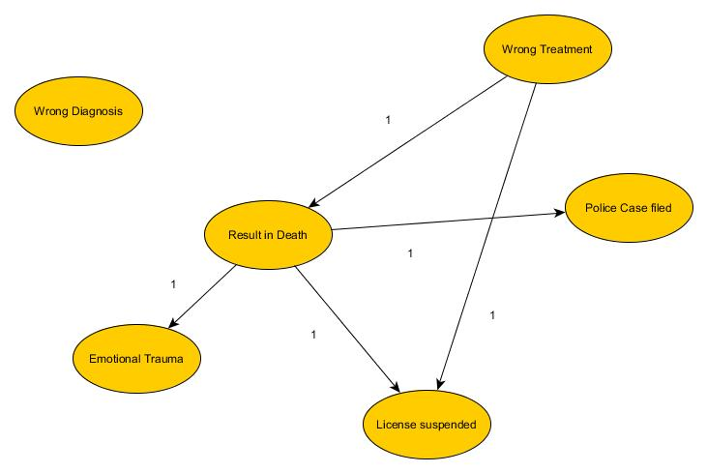

|  |  |  |  |  |  |
| --- | --- | --- | --- | --- | --- |
| WD | WT | ET | PC | Death | LS |
| 0 | 0 | 0 | 0 | 0 | 0 |
| 0 | 0 | 0 | 0 | 1 | 1 |
| 0 | 0 | 0 | 0 | 0 | 0 |
| 0 | 0 | 0 | 0 | 0 | 0 |
| 0 | 0 | 1 | 1 | 0 | 1 |
| 0 | 0 | 0 | 0 | 0 | 0 |

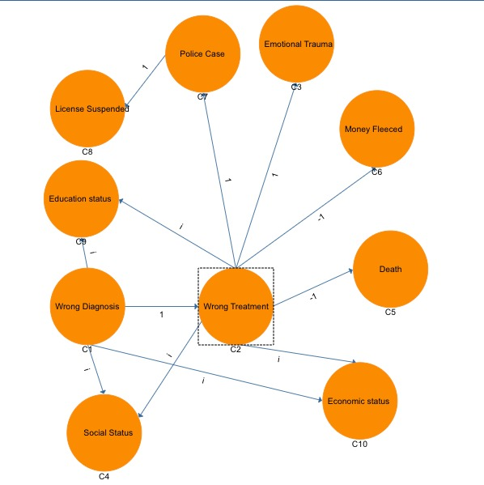

|  |  |  |  |  |  |  |  |  |  |
| --- | --- | --- | --- | --- | --- | --- | --- | --- | --- |
| WD | WT | EduS | SS | EcoS | ET | PC | MF | LS | D |
| 0 | 1 | 0 | 1 | 0 | 0 | 0 | 0 | 0 | 0 |
| 0 | 0 | 0 | 0 | 0 | 1 | 1 | -1 | 0 | -1 |
| 0 | 0 | 0 | 0 | 0 | 0 | 0 | 0 | 0 | 0 |
| 0 | 0 | 0 | 0 | 0 | 0 | 0 | 0 | 0 | 0 |
| 0 | 0 | 0 | 0 | 0 | 0 | 0 | 0 | 0 | 0 |
| 0 | 0 | 0 | 0 | 0 | 0 | 0 | 0 | 0 | 0 |
| 0 | 0 | 0 | 0 | 0 | 0 | 0 | 0 | 1 | 0 |
| 0 | 0 | 0 | 0 | 0 | 0 | 0 | 0 | 0 | 0 |
| 0 | 0 | 0 | 0 | 0 | 0 | 0 | 0 | 0 | 0 |
| 0 | 0 | 0 | 0 | 0 | 0 | 0 | 0 | 0 | 0 |

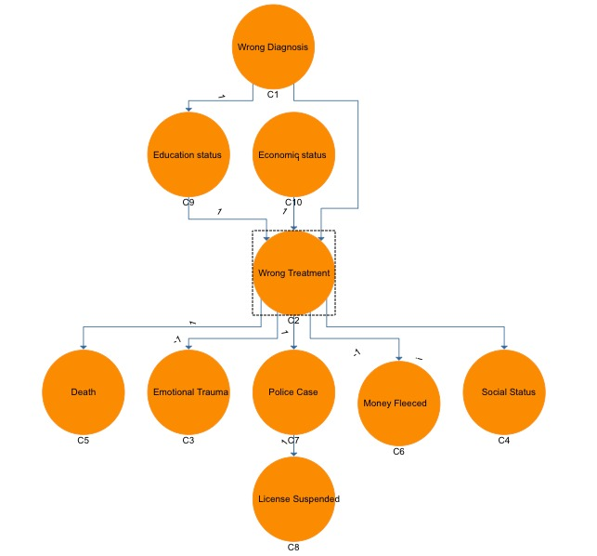

|  |  |  |  |  |  |  |  |  |  |
| --- | --- | --- | --- | --- | --- | --- | --- | --- | --- |
| WD | WT | EduS | SS | EcoS | ET | PC | MF | LS | D |
| 0 | 1 | 1 | 0 | 0 | 0 | 0 | 0 | 0 | 0 |
| 0 | 0 | 0 | 1 | 0 | 1 | 1 | -1 | 0 | 1 |
| 0 | 1 | 0 | 0 | 0 | 0 | 0 | 0 | 0 | 0 |
| 0 | 0 | 0 | 0 | 0 | 0 | 0 | 0 | 0 | 0 |
| 0 | 1 | 0 | 0 | 0 | 0 | 0 | 0 | 0 | 0 |
| 0 | 0 | 0 | 0 | 0 | 0 | 0 | 0 | 0 | 0 |
| 0 | 0 | 0 | 0 | 0 | 0 | 0 | 0 | 1 | 0 |
| 0 | 0 | 0 | 0 | 0 | 0 | 0 | 0 | 0 | 0 |
| 0 | 0 | 0 | 0 | 0 | 0 | 0 | 0 | 0 | 0 |
| 0 | 0 | 0 | 0 | 0 | 0 | 0 | 0 | 0 | 0 |

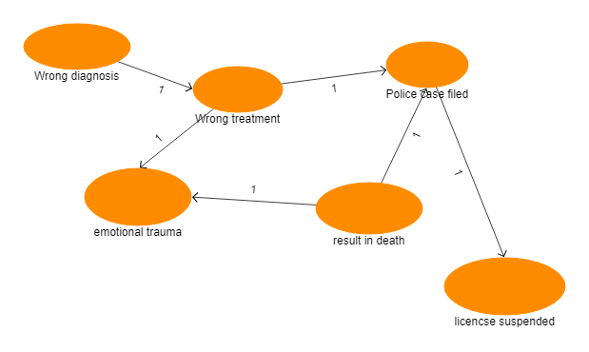

|  |  |  |  |  |  |
| --- | --- | --- | --- | --- | --- |
| WD | WT | ET | PC | Death | LS |
| 0 | 1 | 0 | 0 | 0 | 0 |
| 0 | 0 | 1 | 0 | 0 | 0 |
| 0 | 0 | 0 | 0 | 0 | 0 |
| 0 | 0 | 0 | 0 | 0 | 1 |
| 0 | 0 | 1 | 1 | 0 | 0 |
| 0 | 0 | 0 | 0 | 0 | 0 |

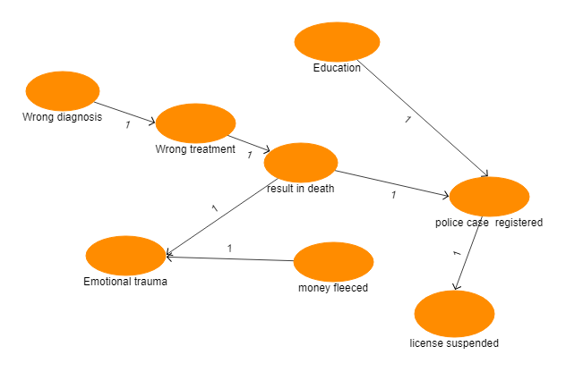

|  |  |  |  |  |  |  |  |
| --- | --- | --- | --- | --- | --- | --- | --- |
| WD | WT | ET | ES | MF | PC | Death | LS |
| 0 | 1 | 0 | 0 | 0 | 0 | 0 | 0 |
| 0 | 0 | 0 | 0 | 0 | 0 | 1 | 0 |
| 0 | 0 | 0 | 0 | 0 | 0 | 0 | 0 |
| 0 | 0 | 0 | 0 | 0 | 1 | 0 | 0 |
| 0 | 0 | 1 | 0 | 0 | 0 | 0 | 0 |
| 0 | 0 | 0 | 0 | 0 | 0 | 0 | 1 |
| 0 | 0 | 1 | 0 | 0 | 1 | 0 | 0 |
| 0 | 0 | 0 | 0 | 0 | 0 | 0 | 0 |

**Implementation (Code)**

install.packages("fcm")

library(fcm)

act.vec <- data.frame(1, 1, 1, 0, 0, 0 )

colnames(act.vec) <- c("C1", "C2", "C3", "C4", "C5", "C6")

C1 = c(0.0, 1.0, 0.0, 0.0, 0.0, 0.0)

C2 = c(0.0, 0.0, 1.0, 0.0, 0.0, 0.0)

C3 = c(0.0, 0.0, 0.0, 0.0, 0.0, 0.0)

C4 = c(0.0, 0.0, 0.0, 0.0, 0.0, 1.0)

C5 = c(0.0, 0.0, 1.0, 1.0, 0.0, 0.0)

C6 = c(0.0, 0.0, 0.0, 0.0, 0.0, 0.0)

w.mat <- matrix(c(C1, C2, C3, C4, C5, C6), nrow =6, ncol=6, byrow=TRUE)

w.mat <- as.data.frame(w.mat)

colnames(w.mat) <- c("C1", "C2", "C3", "C4", "C5", "C6")

w.mat

output1 <- fcm.infer(act.vec, w.mat)

output2 <- fcm.infer(act.vec, w.mat, 35, "r", "s", lambda = 2, e = 0.0001)

output2$values

library (reshape2)

library (ggplot2)

iterations <- as.numeric(rownames(output1$values))

df <- data.frame(iterations, output1$values)

df2 <- melt(df, id="iterations")

ggplot(data=df2,

aes(x=iterations, y=value, group=variable, colour=variable)) +

theme_bw() + geom_line(size=0.7) + geom_point(size = 3)

iterations <- as.numeric(rownames(output2$values))

df <- data.frame(iterations, output2$values)

df2 <- melt(df, id="iterations")

ggplot(data=df2,

aes(x=iterations, y=value, group=variable, colour=variable)) +

theme_bw() + geom_line(size=0.7) + geom_point(size = 3)

**Output**

